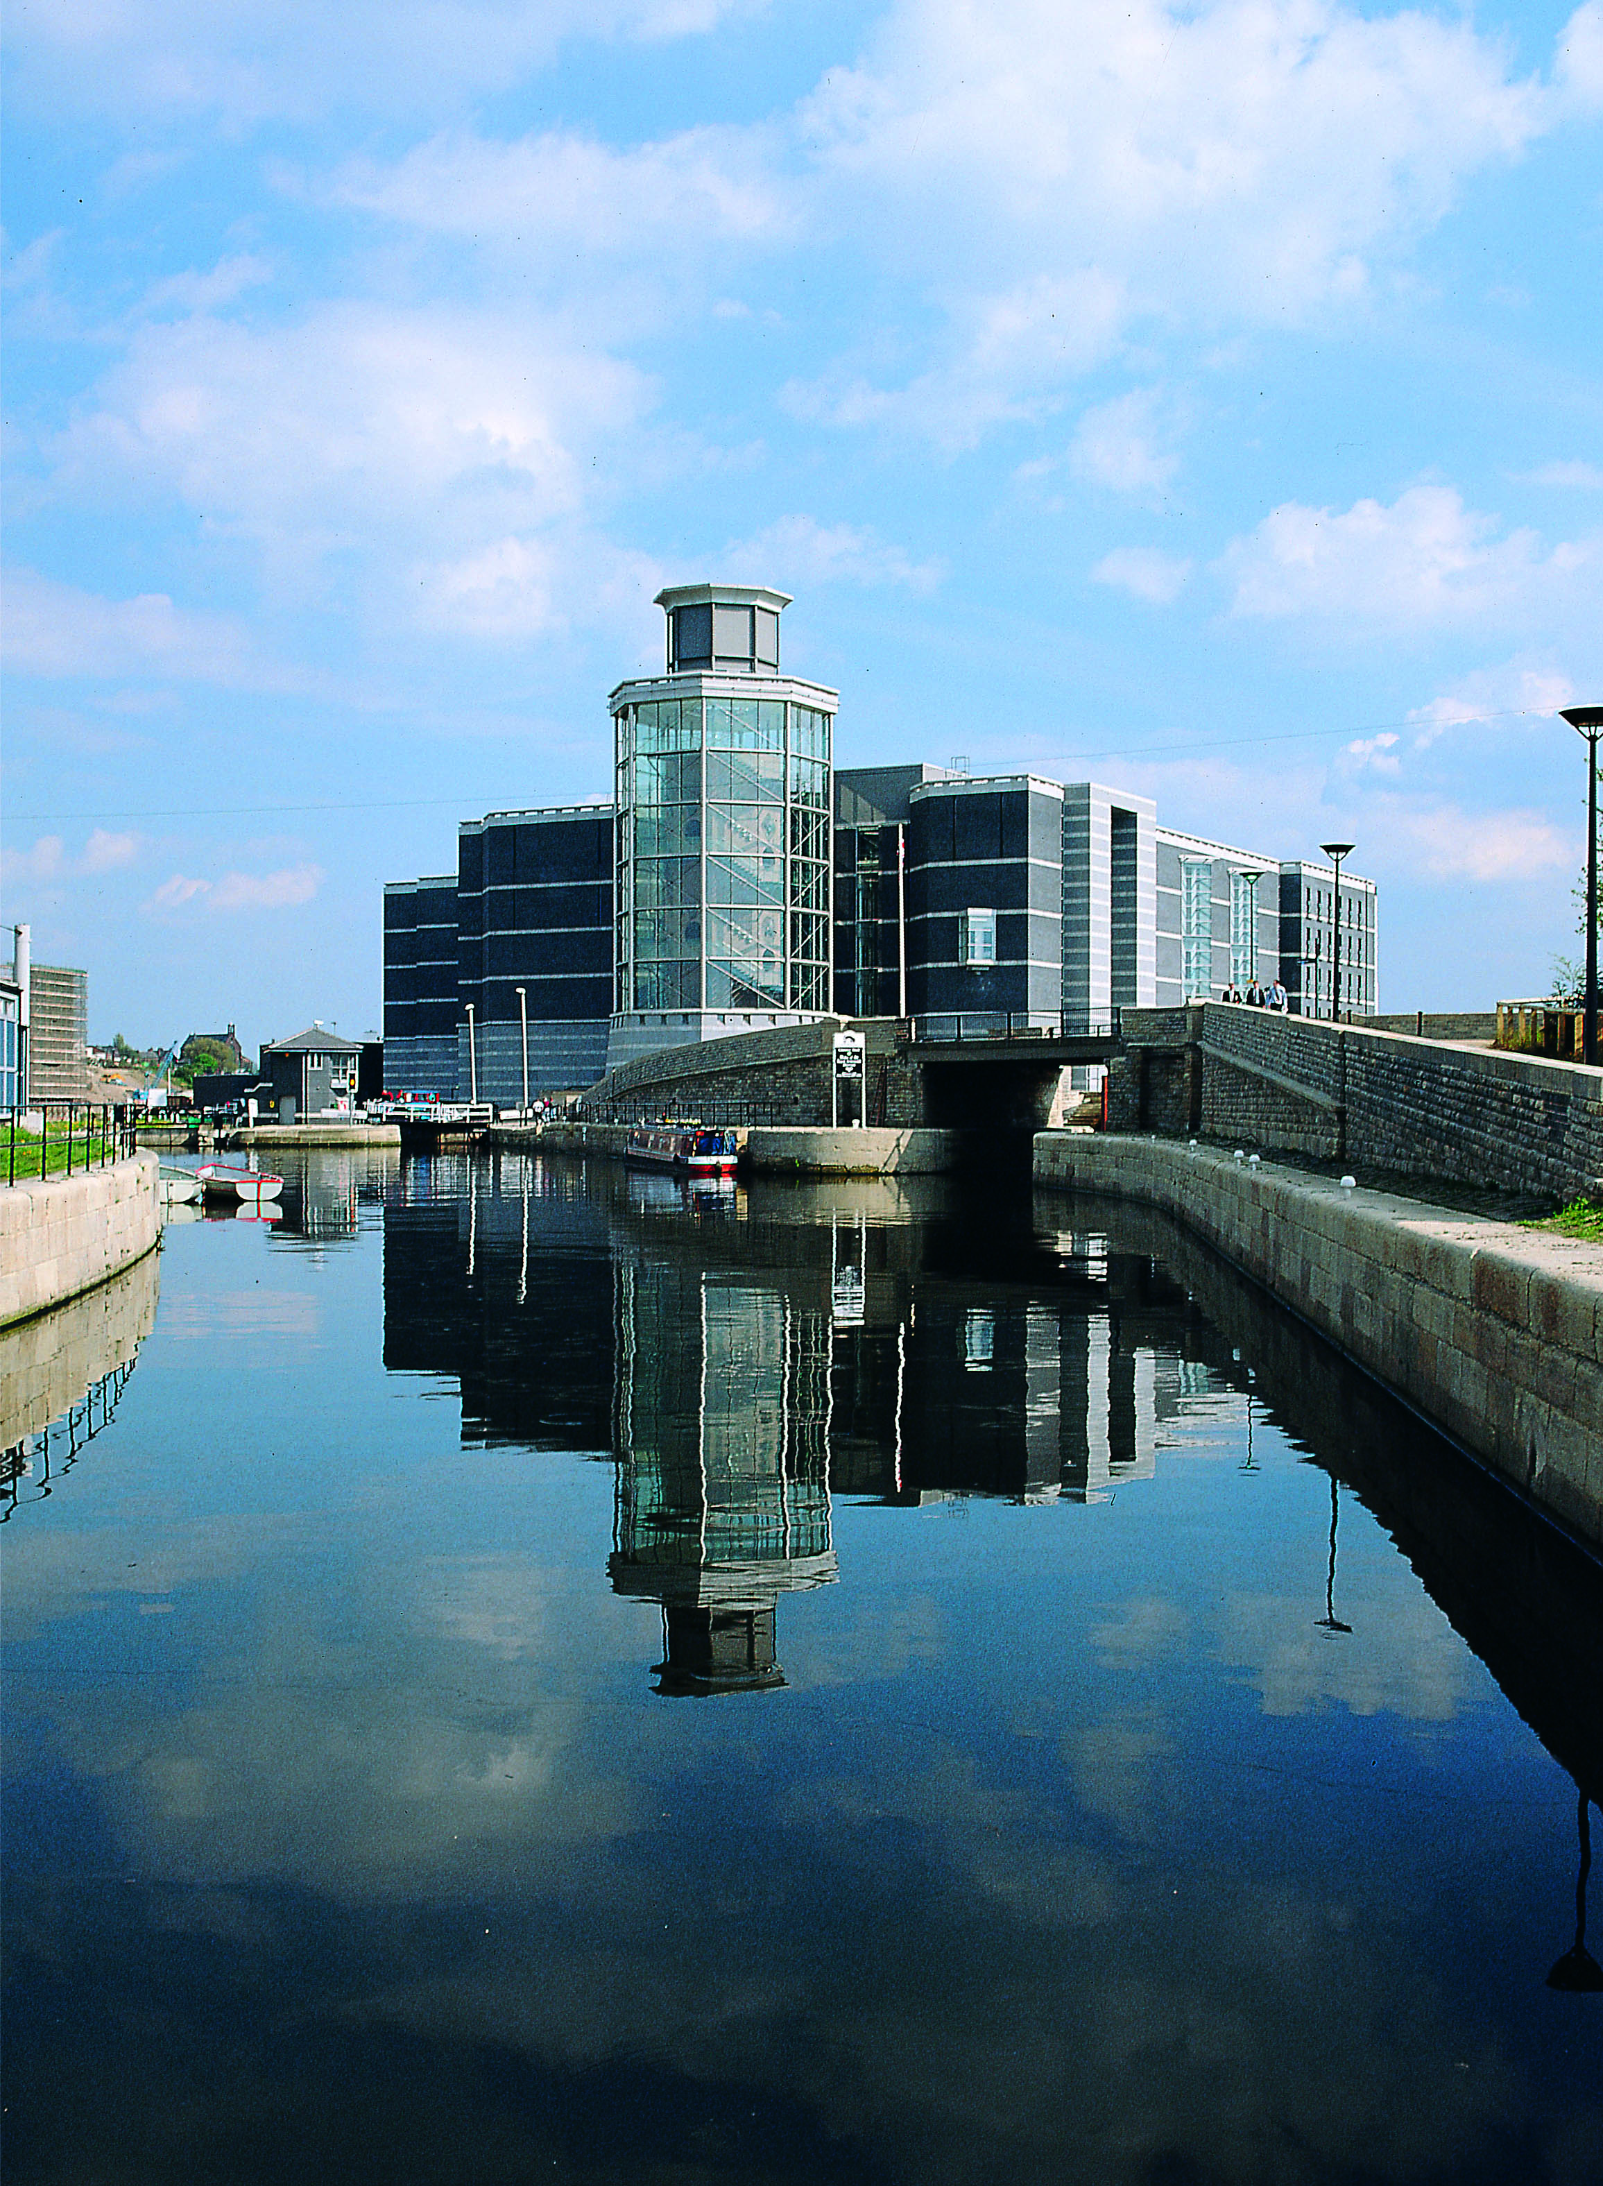

THE CARAVAN AND MOTORHOME CLUB NORTHERN REGION QUESTION TIME
Hosted by Yorkshire Dales and Mid West Yorkshire Centres
To be held on Saturday 28th September 2019
At The Royal Armouries, Armouries Drive, Leeds, LS10 1LT
Arrival: 10.30am Coffee/Tea Meeting starts at 11.00am

The Yorkshire Dales and Mid West Yorkshire Centres, on behalf of the Northern Region, have the pleasure of inviting all members of the Caravan and Motorhome Club to join us at The Royal Armouries for the annual Question Time. The meeting will take place on Saturday 28th September 2019 commencing at 11.00am. This is your chance to ask questions of a panel that will represent the Caravan and Motorhome Club, Caravan Dealers, Repair Agents and anything else that is caravan and motorhome related. A light buffet, tea and coffee will be provided for those attending the meeting.
After the meeting you can look around the Royal Armouries six themed galleries, with free entry. It is a national museum which displays the National Collection of Arms and Armour including Henry VIII’s armour, war histories and experimental weaponry. There is also an opportunity to visit the gift shop and cafes or leisurely sit and have refreshments watching the boats come into the area just outside.

For further information and to assist with catering please contact:
Mrs Sylvia Moran, 0114 2207956, northernregionsec@hotmail.co.uk

